**A Learning Management System (LMS) Specification**

A Learning Management System (LMS) is a software application that facilitates the management, delivery, and tracking of educational courses or training programs. Here's an outline of the key modules and functionalities typically found in an LMS:

**1. User Management Module:**

* **User Roles:** Define roles such as administrators, instructors, students, and possibly other user types.
* **User Registration and Authentication:** Enable users to create accounts, log in, and manage their profiles.
* **User Profiles:** Store user details, preferences, and access permissions.

**2. Course Management Module:**

* **Course Creation:** Allow instructors to create and structure courses.
* **Course Catalog:** Display available courses, descriptions, prerequisites, and schedules.
* **Course Enrollment:** Enable students to enroll in courses and manage their enrolled courses.
* **Content Management:** Upload, organize, and manage course materials like videos, documents, quizzes, assignments, etc.
* **Discussion Forums:** Provide a platform for students and instructors to discuss course-related topics.

**3. Assessment and Evaluation Module:**

* **Quizzes and Tests:** Create and manage assessments with various question types (multiple-choice, essay, etc.).
* **Assignments:** Allow instructors to create assignments and students to submit their work.
* **Grading and Feedback:** Provide grading tools and mechanisms for instructors to evaluate student performance and provide feedback.

**4. Progress Tracking and Reporting Module:**

* **Progress Tracking:** Track and display student progress within courses.
* **Analytics and Reporting:** Generate reports on course completion rates, assessment scores, student engagement, etc.
* **Certificates and Badges:** Award certificates or badges upon completion of courses or certain milestones.

**5. Communication and Collaboration Module:**

* **Messaging:** Enable direct communication between users or user groups.
* **Announcements:** Allow instructors to make announcements about courses.
* **Collaboration Tools:** Offer features for group work, teamwork, or collaborative learning.

**6. Administration and System Management Module:**

* **System Configuration:** Configure system settings, themes, languages, etc.
* **User Management:** Administer user accounts, roles, and permissions.
* **Data Management:** Backup, restore, and manage system data.
* **Integration and Customization:** Support integration with other systems and customizability options.

**7. Mobile Support:**

* **Mobile Application:** Develop a mobile app or ensure responsive design for access on various devices.

**8. Accessibility and Security:**

* **Accessibility:** Ensure the platform is accessible to users with disabilities (ADA compliance).
* **Security:** Implement security measures to protect user data, prevent unauthorized access, and ensure data privacy.

**9. Support and Helpdesk:**

* **Helpdesk and Support:** Provide user support, FAQs, tutorials, and help documentation.
* **Feedback and Improvement:** Collect feedback to improve the platform's usability and functionality.

Each module can contain multiple features and functionalities. Customization and additional modules may be required based on specific use cases, such as corporate training, academic institutions, or specialized training programs.

**Core Entities and relationship diagram**

An Entity-Relationship Diagram (ERD) visually represents the entities within a system and their relationships. In the context of a Learning Management System (LMS), here's a simplified example of an ERD representing some of the key entities and their relationships:

Entities:

1. User:
   * Attributes: UserID (Primary Key), Username, Email, Password, UserType (Student, Instructor, Admin), etc.
2. Course:
   * Attributes: CourseID (Primary Key), CourseName, Description, InstructorID (Foreign Key), etc.
3. Enrollment:
   * Attributes: EnrollmentID (Primary Key), UserID (Foreign Key), CourseID (Foreign Key), EnrollmentDate, etc.
4. Content:
   * Attributes: ContentID (Primary Key), CourseID (Foreign Key), Title, Type (Video, Document, Quiz), FileURL, etc.
5. Assessment:
   * Attributes: AssessmentID (Primary Key), CourseID (Foreign Key), Title, Type (Quiz, Assignment), etc.

Relationships:

* User - Enrollment: Many-to-Many relationship between User and Course through Enrollment.
* User - Course: Represents the enrolled courses for each user.
* Course - Content: One-to-Many relationship; a course can have multiple content items (videos, documents, quizzes).
* Course - Assessment: One-to-Many relationship; a course can have multiple assessments (quizzes, assignments).

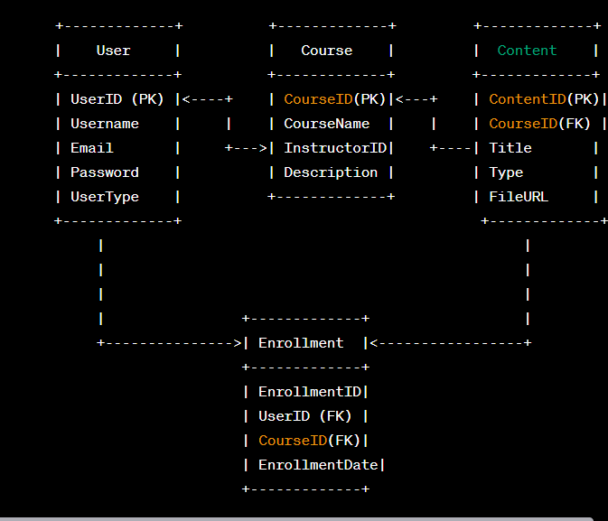

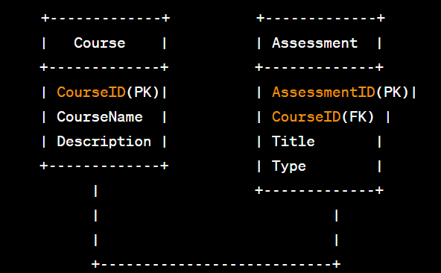

This is a basic representation, and in a real-world scenario, the ERD would likely include more entities, attributes, and relationships to capture the full complexity of an LMS. Also, depending on specific business rules and requirements, cardinality, and participation constraints, the relationships might vary.

In a Java Spring Boot-based Learning Management System (LMS), the architecture is typically divided into various modules, each handling different functionalities. Here's a breakdown of possible modules and the associated technical stack:

**Modules:**

1. **User Management Module:**
   * **Functionality:** Handles user authentication, registration, profiles, and permissions.
   * **Technical Stack:** Spring Security, JWT (JSON Web Tokens), Spring Data JPA for user data management.
2. **Course Management Module:**
   * **Functionality:** Manages courses, modules, lessons, and content.
   * **Technical Stack:** Spring MVC for handling course-related requests, Spring Data JPA for database operations, possibly using Hibernate for ORM.
3. **Assessment and Evaluation Module:**
   * **Functionality:** Handles quizzes, tests, assignments, grading, and assessment feedback.
   * **Technical Stack:** Spring MVC for handling assessment-related requests, database operations using Spring Data JPA.
4. **Content Management Module:**
   * **Functionality:** Manages multimedia content, documents, resources.
   * **Technical Stack:** Amazon S3 or other cloud storage for content storage, Spring MVC for content management APIs, Spring Data JPA for database operations.
5. **Communication and Collaboration Module:**
   * **Functionality:** Facilitates communication between users, forums, announcements, etc.
   * **Technical Stack:** Spring WebSockets or messaging services for real-time communication, Spring MVC for RESTful APIs.
6. **Reporting and Analytics Module:**
   * **Functionality:** Tracks student progress, generates reports, provides analytics.
   * **Technical Stack:** Data processing libraries, Spring Batch for scheduled jobs, visualization tools (e.g., Chart.js) for reporting.
7. **Administration and System Management Module:**
   * **Functionality:** Manages system configurations, backup, restores, data management.
   * **Technical Stack:** Spring MVC for admin-related APIs, Spring Batch for background jobs, and management tasks.
8. **Mobile Support Module:**
   * **Functionality:** Provides a mobile-friendly or native mobile app interface for the LMS.
   * **Technical Stack:** React Native, Flutter, or other cross-platform mobile frameworks, Spring Boot for RESTful APIs.

**Common Technical Stack:**

* **Framework:** Spring Boot for overall application development.
* **Database:** MySQL, PostgreSQL, or other relational databases. Optionally, NoSQL databases like MongoDB for specific functionalities.
* **Frontend:** React, Angular, or Vue.js for the user interface.
* **Authentication:** Spring Security with JWT or OAuth2 for user authentication and authorization.
* **ORM:** Spring Data JPA with Hibernate for database access and object-relational mapping.
* **Messaging:** Apache Kafka or RabbitMQ for asynchronous messaging in the system.
* **File Storage:** Amazon S3, Azure Blob Storage, or local file storage for handling multimedia content.
* **Deployment:** Docker for containerization, Kubernetes for orchestration, AWS, Azure, or Google Cloud for cloud hosting.

The choice of technology stack can vary based on specific requirements, scalability needs, team expertise, and other factors. The outlined modules and technologies provide a starting point for architecting an LMS in Java using Spring Boot. Adjustments and enhancements may be needed based on the project's unique requirements.